SITE: [PROJECT_NAME]
SYSTEM TYPE: [RACKING_TYPE], [RACKING_LOCATION]
LOCATION: [ADDRESS]
DC SYSTEM SIZE: [DC_CAPACITY] kW-DC
AC SYSTEM SIZE: [AC_CAPACITY] kW-AC
INVERTERS: [INV_1_COUNT] [INV_1_TYPE]
[INV_2_COUNT] [INV_2_TYPE]
MODULES: [MOD_COUNT] [MOD_TYPE]
MLPE/RSD: [MLPE_COUNT] [MLPE_TYPE]
INTERCONNECTION: [IX_TYPE] [IX-VOLTAGE]

[SECTION_START]
[ISSUE_ID] – [LOCATION]
Inspection Comment:
[INSPECTION_COMMENT]

Contractor Response:
[CONTRACTOR_RESPONSE]

ANTARES Response:
[AGI_COMMENT]
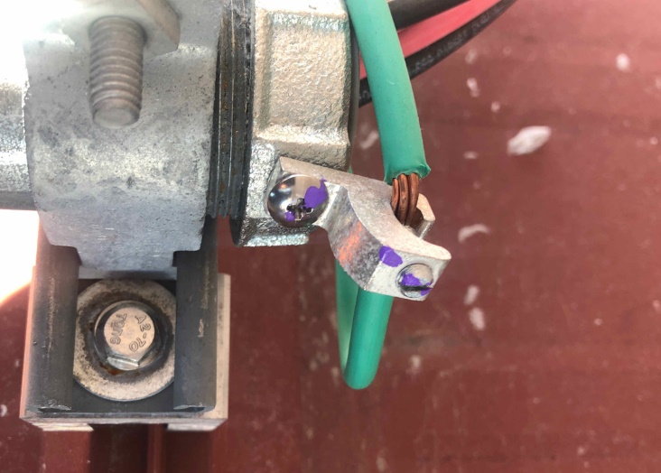
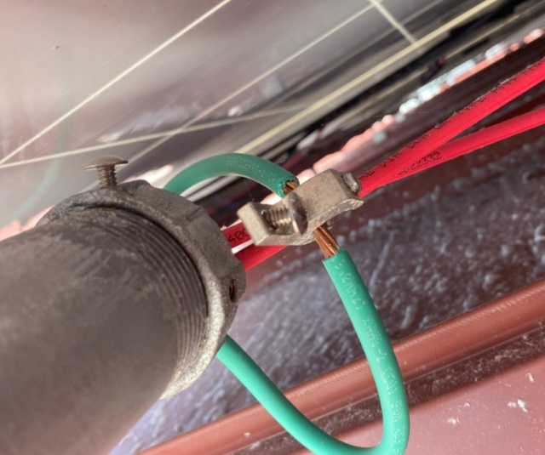

[SECTION_END]

